Analysing the relationship Between Research and Ideas Development

Interior design is an art form that combines creativity and functionality, and that requires a deep understanding of space, aesthetics, and human behaviour. Central to this process is the interplay between research and idea development. In this article, we will explore the critical relationship between these elements, how to conduct effective research, and strategies for developing ideas in the initial stages of a project.

Before we continue, it is important to understand the difference between academic research (the research you will be conducting in order to respond to your assignments), and the research carried out as an Interior Designer, when looking for inspiration and during the process of Idea Generation. Research for academia involves the collection of data, which is cited and referenced appropriately, in order to support and validate the development of your critical thinking and knowledge. Research carried out within the realm of an Interior Design Project, and in the Industry, as a professional Interior Designer, focuses on examples that will act as springboards to further develop ideas, inspiration and solutions for developing projects.

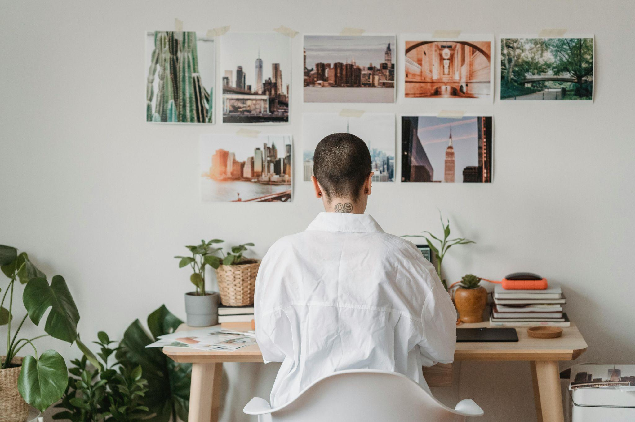

Fig 1. Pexels (n.d.), Interior Designer at work

# The Relationship Between Research and Idea Development

As mentioned above, research and idea development are interdependent processes. Research provides a solid foundation upon which creative ideas can be built, guaranteeing they are both practical and innovative. By investigating the latest trends, materials, technologies, and historical influences, as a designer, you can draw inspiration and validate your concepts. In addition to this, research can uncover new materials, techniques, and trends that spark innovative ideas. On the flip side, the process of idea generation can reveal gaps in your knowledge that may require further research, creating a continuous feedback loop that enhances the overall design process.

For example, understanding cultural preferences and historical contexts, can lead to designs that resonate deeply with your client. Similarly, researching sustainable materials and technologies enables you to create eco-friendly spaces that meet contemporary environmental standards.

# Conducting Research for Idea Generation in

Interior Design.

As a professional Interior Designer, generating innovative and effective interior design ideas requires a robust research process. Research helps you as a designer to understand trends, client needs, and technical requirements, and enables you to create spaces that are both beautiful and functional. Here’s a comprehensive guide on how to conduct research for idea generation in Interior Design.



Fig 2. Canva (n.d.), An Interior Design student conducting research

## Step 1: Engage with Clients and Stakeholders

Understanding your client's needs, preferences, and lifestyle is the first step in generating relevant design ideas. Conduct interviews in order to profile them and develop a client brief. Include questions about:

Their daily routines and how they use the space.

Specific dislikes or preferences for colours, materials, and styles.

Any functional requirements or challenges they face in their current space.

## Step 2: Define Your Research Objectives

Before diving into the research, you must establish clear objectives.

Ask yourself:

What is the purpose of this research? (Am I looking for colour inspiration, layout solutions, style inspiration etc).

What specific information am I seeking? (Particular colour trends, paint brands, etc.) 

What are the goals for the design project? (Think of the client brief)

Defining these objectives will help you stay focused, and ensure that your research efforts are aligned with your project needs.

## Step 3: Identify Your Sources

Identify a variety of sources that can provide valuable information.

These sources can include:

Books and Magazines: Look for publications on interior design, architecture, and related fields. Magazines often provide more up-to-date trends and recent projects.

Online Resources: Websites, blogs, and online magazines can offer up-to-date information on trends and new products.

Industry Reports: Reports from industry associations or market research firms, such as [Trend](https://www.trendbible.com/industry-trend-forecasts/home-and-interior-trends/) [Bible](https://www.trendbible.com/industry-trend-forecasts/home-and-interior-trends/), can provide insights into market trends and consumer preferences.

Case Studies: Reviewing your own past projects can help you understand how different design solutions were implemented and their outcomes.



Fig 3. Pexels (n.d.), Image of an Interior Designer at their desk

## Step 4: Explore Trends and Inspirations

Stay updated on the latest trends in interior design. Use platforms like Pinterest, Instagram, and design-focused websites to gather inspiration. Create mood boards to visualise different concepts and styles. Trends can provide a starting point, but always tailor them to fit the specific needs and context of your project.

## Step 5: Conduct Site Visits and Observations

Where possible, visiting sites similar to your project can provide first-hand insights. For example, if you are creating a mid-century modern space, you could source and visit an original build from that era.

Observe the layout, materials used, lighting, and overall ambiance. Take notes and photographs for reference. Pay attention to how people interact with the space, as this can inform your design decisions.

## Step 6: Analyse Collected Data

Once you have gathered a substantial amount of information, it’s time to analyse it. Look for patterns, common themes, and unique insights. You will usually find that you are gravitating toward certain images with a repetition of material finishes or specific colour schemes.

Organise the information into relevant groups such as materials, colour schemes, space utilisation, etc.



Fig 4. Canva (n.d.), Image of an Interior Designer at their desk

Conducting thorough research is integral to generating innovative and effective interior design ideas. By following this guide, you can ensure that your designs are well-informed, functional, and aesthetically pleasing. Embrace the research process as a foundation for your creativity, enabling you to create spaces that truly meet the needs and desires of your clients.

We will now look at how to use this research in order to navigate the process of Idea Generation:

# Guide for Idea Generation as a professional

Interior Designer.

Ideas do not always come easily and while interior designers are creative minded people, there will always be periods when the ideas just don’t seem to flow. Here are some techniques that can help you enhance your creative thinking, and come up with unique design solutions like a professional:

## Brainstorming

**Individual Brainstorming**: Take some quiet time to jot down every idea that comes to mind, no matter how wild or impractical it may seem. Aim for quantity over quality initially.

**Group Brainstorming**: Collaborate with classmates or colleagues to generate ideas collectively. Use tools like whiteboards or sticky notes to visualise and organise thoughts. **Mind Mapping**: Create a visual representation of your ideas, connected to a central theme. This helps to envision relationships between different concepts, and can generate new thoughts.



Fig 5. Canva (n.d.), Image of an Interior Designer mind mapping

## Mood Boards / Concept Boards

Collect images, textures, colours, and objects that inspire you. Arrange these elements on a board (physical or digital), creating a visual collage that captures the essence of your design vision.

Use tools like Canva, Adobe Spark or Power Point for digital mood boards, or create physical boards using magazine cutouts, fabric swatches, and paint samples.

## Sketching and Doodling

Quick, freehand sketches can help you explore shapes, forms, and layouts without the pressure of perfection. Keep a sketchbook handy to capture spontaneous ideas.

Use rough sketches to visualise spatial arrangements, furniture placements, and decorative elements.



Fig 6. Canva (n.d.), Image of Interior Designers mind mapping

## Workshops and Collaborative Sessions

Often, if you are a freelance interior designer, it is quite hard to bounce ideas off other colleagues. Taking part in design workshops or collaborative sessions with peers, mentors, or industry professionals can be helpful. There are many online groups where you can take part in collaborative sessions. These environments often foster creative thinking and can provide a greater diversity of perspectives.

## Random Input/ Analogies and metaphors

Introduce random stimuli to your thought process. Use books, photographs, or objects unrelated to interior design to spark new ideas and break out of conventional thinking patterns.

Use analogies and metaphors to draw parallels between unrelated concepts and your design project. This can help to conceptualise abstract ideas and make them more concrete. For example, using the shape of a snowflake for a floor plan.

## Role-Playing and Scenario Planning

This is a necessary process in every Interior Design project, however, in some cases, it is helpful to immerse yourself into the scenario further. Imagine yourself as the end-user of the space, and walk through various scenarios. This technique helps in understanding the practical aspects and usability of your design concepts.

## Incorporating Technology

Sometimes, especially if we are looking at an unusual or intricate layout, we struggle with finding solutions for possible furniture layouts. By implementing design software and virtual reality tools to experiment with different layouts, colour schemes, and furniture arrangements in a simulated environment, we are able to work around such challenges.

Tools like AutoCAD, SketchUp, and Revit can help in visualising and refining your ideas digitally.

## Reverse Engineering through Generative AI Imagery**

Firstly, let’s explain what Generative AI imagery is: Creating generative AI imagery, the process of generating images, from text descriptions, on certain AI platforms that facilitate this function. Platforms like DALL-E, MidJourney, or Stable Diffusion can generate design concepts from text descriptions.

Application:

Use AI-generated imagery as a starting point or inspiration, blending it with your own creative input to develop a unique and personalised design.

Experiment with tweaking the inputs in the AI tool, to see how different parameters affect the output. This iterative process can lead to unexpected and innovative design ideas.

** Please always make sure you use AI ethically in your practices.

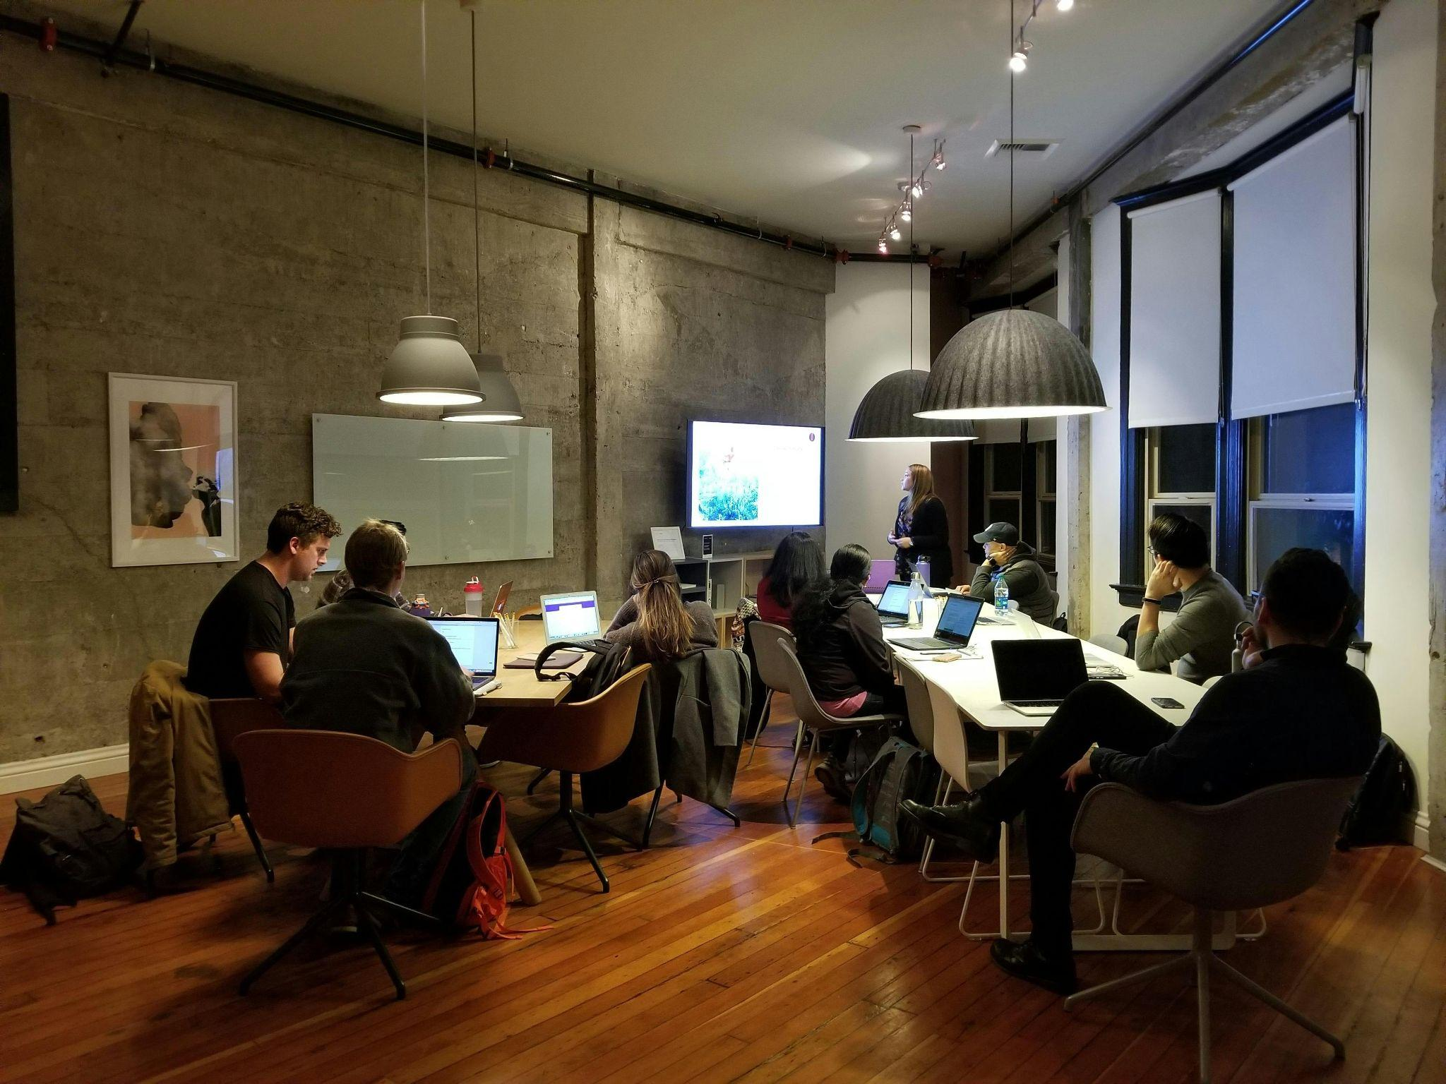

Fig 7. Canva (n.d.), Image of an Interior Design Studio Meeting Room

By employing these techniques, you can enhance your creativity, generate a diverse range of ideas, and develop well-rounded and innovative design solutions. Remember, the key to successful idea generation is to remain open-minded, curious, with a willingness to explore new possibilities.